**Day 42**

**Multithreading in Java**

**Multithreading in**[**Java**](https://www.javatpoint.com/java-tutorial) is a process of executing multiple threads simultaneously.

A thread is a lightweight sub-process, the smallest unit of processing. Multiprocessing and multithreading, both are used to achieve multitasking.

However, we use multithreading than multiprocessing because threads use a shared memory area. They don't allocate separate memory area so saves memory, and context-switching between the threads takes less time than process.

Java Multithreading is mostly used in games, animation, etc.

Advantages of Java Multithreading

1) It **doesn't block the user** because threads are independent and you can perform multiple operations at the same time.

2) You **can perform many operations together, so it saves time**.

3) Threads are **independent**, so it doesn't affect other threads if an exception occurs in a single thread.

Multitasking

Multitasking is a process of executing multiple tasks simultaneously. We use multitasking to utilize the CPU. Multitasking can be achieved in two ways:

* Process-based Multitasking (Multiprocessing)
* Thread-based Multitasking (Multithreading)

1) Process-based Multitasking (Multiprocessing)

* Each process has an address in memory. In other words, each process allocates a separate memory area.
* A process is heavyweight.
* Cost of communication between the process is high.
* Switching from one process to another requires some time for saving and loading [registers](https://www.javatpoint.com/register-memory), memory maps, updating lists, etc.

2) Thread-based Multitasking (Multithreading)

* Threads share the same address space.
* A thread is lightweight.
* Cost of communication between the thread is low.

Note: At least one process is required for each thread.

What is Thread in java

A thread is a lightweight subprocess, the smallest unit of processing. It is a separate path of execution.

Threads are independent. If there occurs exception in one thread, it doesn't affect other threads. It uses a shared memory area.

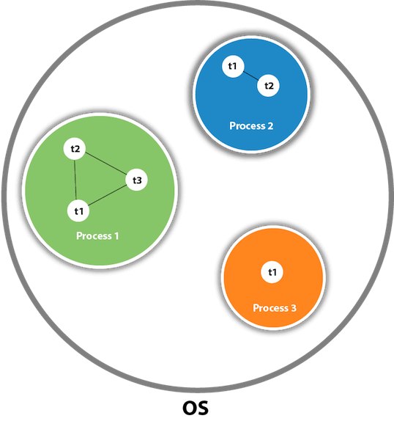

As shown in the above figure, a thread is executed inside the process. There is context-switching between the threads. There can be multiple processes inside the [OS](https://www.javatpoint.com/os-tutorial), and one process can have multiple threads.

Note: At a time one thread is executed only.

Java Thread class

Java provides **Thread class** to achieve thread programming. Thread class provides [constructors](https://www.javatpoint.com/java-constructor) and methods to create and perform operations on a thread. Thread class extends [Object class](https://www.javatpoint.com/object-class) and implements Runnable interface.

Java Thread Methods

|  |  |  |  |
| --- | --- | --- | --- |
| **S.N.** | **Modifier and Type** | **Method** | **Description** |
| 1) | void | [start()](https://www.javatpoint.com/java-thread-start-method) | It is used to start the execution of the thread. |
| 2) | void | [run()](https://www.javatpoint.com/java-thread-run-method) | It is used to do an action for a thread. |
| 3) | static void | [sleep()](https://www.javatpoint.com/java-thread-sleep-method) | It sleeps a thread for the specified amount of time. |
| 4) | static Thread | [currentThread()](https://www.javatpoint.com/java-thread-currentthread-method) | It returns a reference to the currently  executing thread object. |
| 5) | void | [join()](https://www.javatpoint.com/java-thread-join-method) | It waits for a thread to die. |
| 6) | int | [getPriority()](https://www.javatpoint.com/java-thread-getpriority-method) | It returns the priority of the thread. |
| 7) | void | [setPriority()](https://www.javatpoint.com/java-thread-setpriority-method) | It changes the priority of the thread. |
| 8) | String | [getName()](https://www.javatpoint.com/java-thread-getname-method) | It returns the name of the thread. |
| 9) | void | [setName()](https://www.javatpoint.com/java-thread-setname-method) | It changes the name of the thread. |
| 10) | long | [getId()](https://www.javatpoint.com/java-thread-getid-method) | It returns the id of the thread. |
| 11) | boolean | [isAlive()](https://www.javatpoint.com/java-thread-isalive-method) | It tests if the thread is alive. |
| 12) | static void | [yield()](https://www.javatpoint.com/java-thread-yield-method) | It causes the currently executing  thread object to pause and allow  other threads to execute temporarily. |
| 13) | void | [suspend()](https://www.javatpoint.com/java-thread-suspend-method) | It is used to suspend the thread. |
| 14) | void | [resume()](https://www.javatpoint.com/java-thread-resume-method) | It is used to resume the suspended thread. |
| 15) | void | [stop()](https://www.javatpoint.com/java-thread-stop-method) | It is used to stop the thread. |
| 16) | void | [destroy()](https://www.javatpoint.com/java-thread-destroy-method) | It is used to destroy the thread group  and all of its subgroups. |
| 17) | boolean | [isDaemon()](https://www.javatpoint.com/java-thread-isdaemon-method) | It tests if the thread is a daemon thread. |
| 18) | void | [setDaemon()](https://www.javatpoint.com/java-thread-setdaemon-method) | It marks the thread as daemon or user thread. |
| 19) | void | [interrupt()](https://www.javatpoint.com/java-thread-interrupt-method) | It interrupts the thread. |
| 20) | boolean | [isinterrupted()](https://www.javatpoint.com/java-thread-isinterrupted-method) | It tests whether the thread has been interrupted. |
| 21) | static boolean | [interrupted()](https://www.javatpoint.com/java-thread-interrupted-method) | It tests whether the current thread has  been interrupted. |
| 22) | static int | [activeCount()](https://www.javatpoint.com/java-thread-activecount-method) | It returns the number of active threads  in the current thread's thread group. |
| 23) | void | [checkAccess()](https://www.javatpoint.com/java-thread-checkaccess-method) | It determines if the currently running  thread has permission to modify the thread. |
| 24) | static boolean | [holdLock()](https://www.javatpoint.com/java-thread-holdlock-method) | It returns true if and only if the current thread  holds the monitor lock on the specified object. |
| 25) | static void | [dumpStack()](https://www.javatpoint.com/java-thread-dumpstack-method) | It is used to print a stack trace of the current  thread to the standard error stream. |
| 26) | StackTraceElement[] | [getStackTrace()](https://www.javatpoint.com/java-thread-getstacktrace-method) | It returns an array of stack trace elements  representing the stack dump of the thread. |
| 27) | static int | [enumerate()](https://www.javatpoint.com/java-thread-enumerate-method) | It is used to copy every active thread's  thread group and its subgroup into the specified  array. |
| 28) | Thread.State | [getState()](https://www.javatpoint.com/java-thread-getstate-method) | It is used to return the state of the thread. |
| 29) | ThreadGroup | [getThreadGroup()](https://www.javatpoint.com/java-thread-getthreadgroup-method) | It is used to return the thread group to which  this thread belongs |
| 30) | String | [toString()](https://www.javatpoint.com/java-thread-tostring-method) | It is used to return a string representation of  this thread, including the thread's name, priority,  and thread group. |
| 31) | void | [notify()](https://www.javatpoint.com/java-thread-notify-method) | It is used to give the notification for only  one thread which is waiting for a particular object. |
| 32) | void | [notifyAll()](https://www.javatpoint.com/java-thread-notifyall-method) | It is used to give the notification to all  waiting threads of a particular object. |
| 33) | void | [setContextClassLoader()](https://www.javatpoint.com/java-thread-setcontextclassloader-method) | It sets the context ClassLoader for the Thread. |
| 34) | ClassLoader | [getContextClassLoader()](https://www.javatpoint.com/java-thread-getcontextclassloader-method) | It returns the context ClassLoader for the thread. |
| 35) | static Thread.UncaughtExceptionHandler | [getDefaultUncaughtExceptionHandler()](https://www.javatpoint.com/java-thread-getdefaultuncaughtexceptionhandler-method) | It returns the default handler invoked when a thread abruptly terminates due to an uncaught exception. |
| 36) | static void | [setDefaultUncaughtExceptionHandler()](https://www.javatpoint.com/java-thread-setdefaultuncaughtexceptionhandler-method) | It sets the default handler invoked when a thread abruptly terminates due to an uncaught exception. |